


On Line Listening

This pack has been produced to support you as you learn to listen with your new cochlear implant. These on line resources are part of the listening rehabilitation programme you have agreed with your speech and language therapist.
- If you have a smart phone, laptop or tablet there are a lot of listening activities to access.
- We have put together some ideas for you to try at home.

How this helps with active listening
- These activities will help you to find ways to listen when you are alone.
- On line listening can give you different things to try and different voices to listen to.
- You can make on line listening as challenging as you want (depending on your listening level).
- It is good to have a mix of different listening activities through your day and having some on line targets will help you structure your listening plan.
But I’m not very confident on the internet or with my phone!

No problem! Recruit your friends, parents, children and grandchildren if you need to. We’ll help you too if you are finding it difficult to get started.
Listening practice for speech

- These are listening exercises for adults made by Advanced Bionics. You will need to register and make a log in to use the exercises but it is worth it. You can access their internet site at https://www.hearingsuccess.com
- There are a range of speech exercises and you can work at your level and move on to challenging exercises when you are ready.
- The exercises are given by different speakers and you can listen and lip read or turn off the video so you are just using your listening to work out the answers.
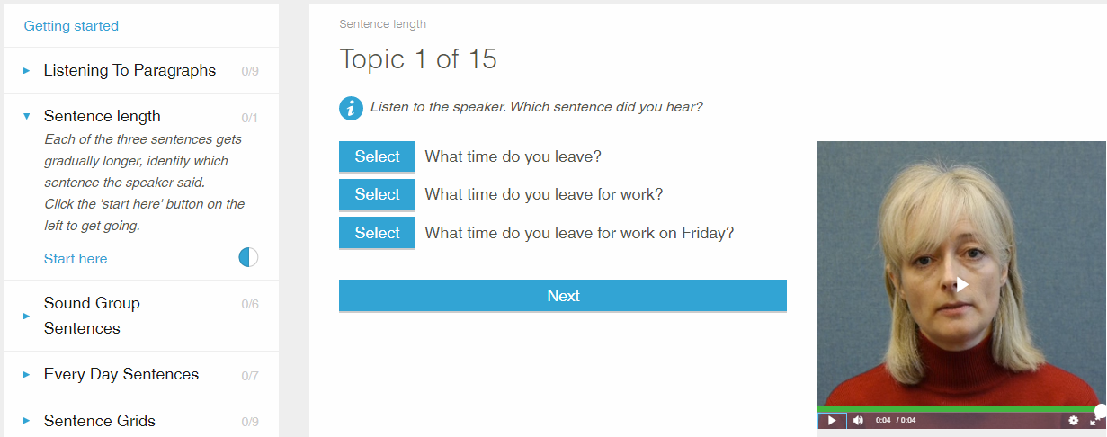

Angel Sound

- You can download this app from Apple (only for iPad/iPhone users)
- This has a lot of speech exercises but also activities to help you recognise background sounds and music

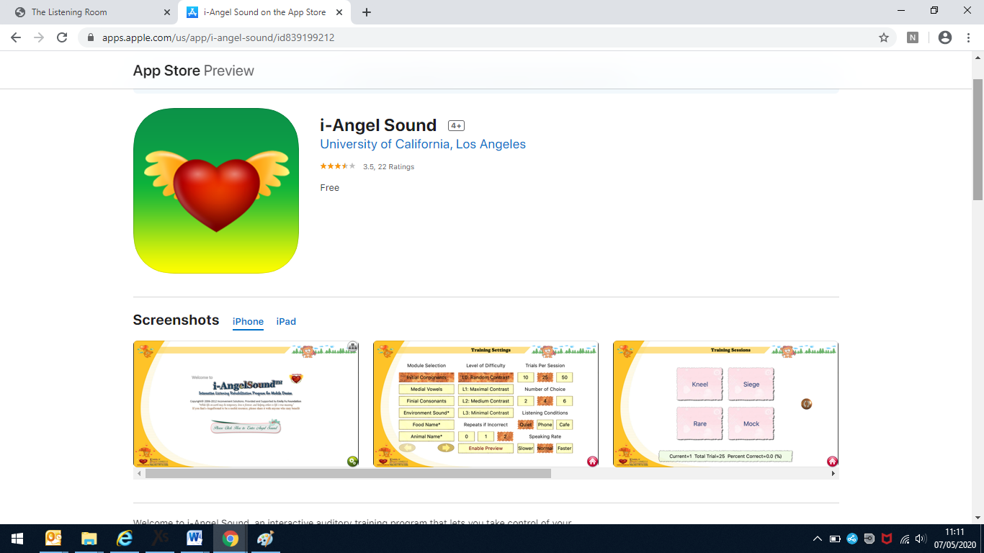

Hear Coach (Starkey Laboratories)

- You can download this app from Google Play or Apple.
- It has some useful speech exercises to work through

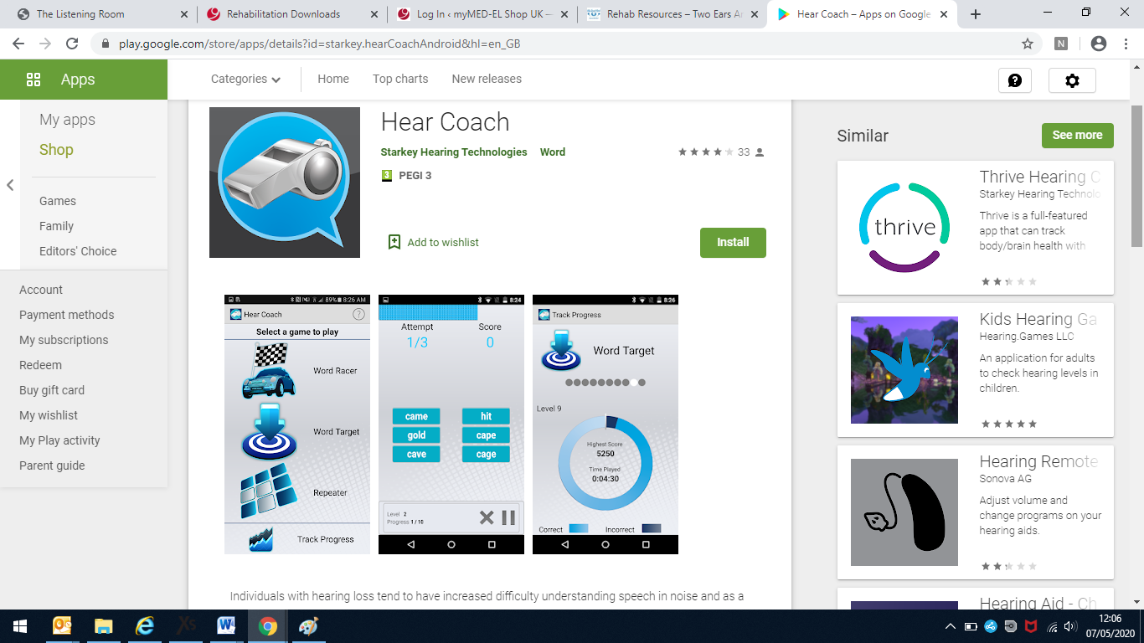

Hearoes (https://www.games4hearoes.com/)

- Another app that can be downloaded from Google Play or Apple
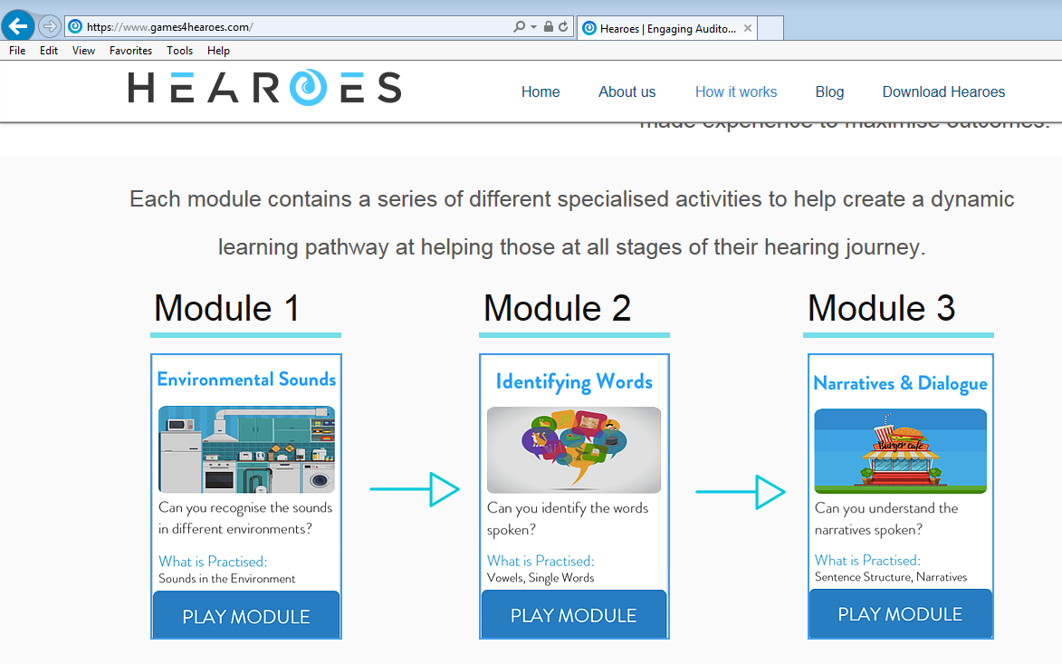
Other ways to listen to speech

- Try listening to some speech radio programmes. Expect this to be hard; you might only pick out some words or phrases at first.
- Try listening to radio through websites or apps. BBC Sounds is a good example. You’ll be able to stop, start or rewind the programme.

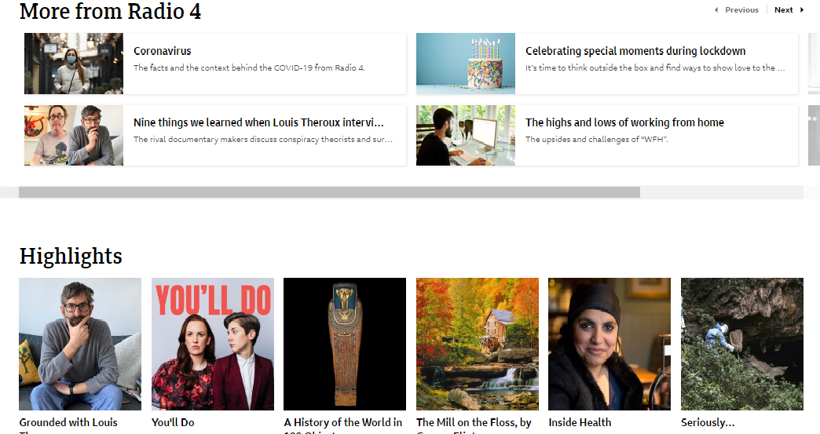
Try Audiobooks
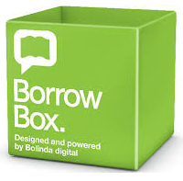
- Audiobooks are a very popular and useful way to practice listening to speech.
- If you belong to your library check to see if they are using a service like BorrowBox (or RB Digital) which will have a selection of audiobooks for loan.
- There are other popular audiobook providers like Audible which are worth looking at and which have a wider selection (but aren’t free).
- When you are starting with audiobooks make sure you have a copy of the actual book as well. Audiobooks are challenging and you might need the written form to back you up if you struggle at first.

Try YouTube

- YouTube is worth investigating. It has vast amount of useful listening material.
- Find videos where people are reading familiar poems or stories or books.
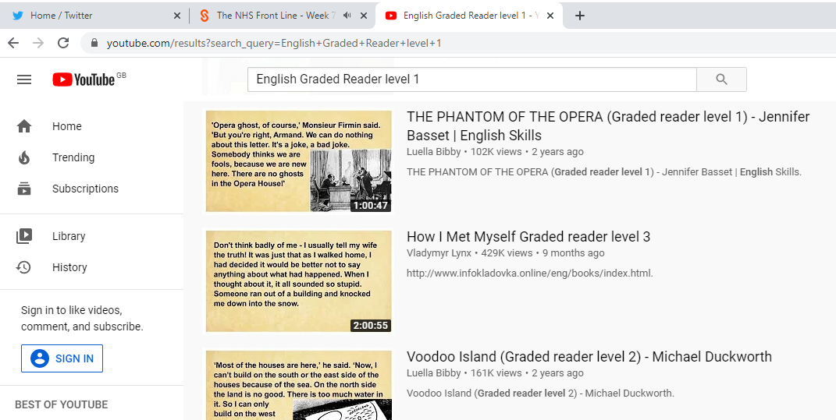
- Try a resource like English Graded Reader (below) where you can listen to stories with text back up.

- ‘English Graded Reader’ is a resource for people learning English as an additional language so the speech is clear and not too fast.
Resources for People Learning English

- Another resource like English Graded Reader is available from The British Council who have on line activities to help people learn English.
- Try the listening comprehension passages.
- There are different speakers to listen to.
- There is a transcript to turn on and off as needed.
- You’ll hear different voices and accents and there is sometimes underlying background noise.
- This listening is quite challenging!

https://learnenglish.britishcouncil.org/skills/listening/

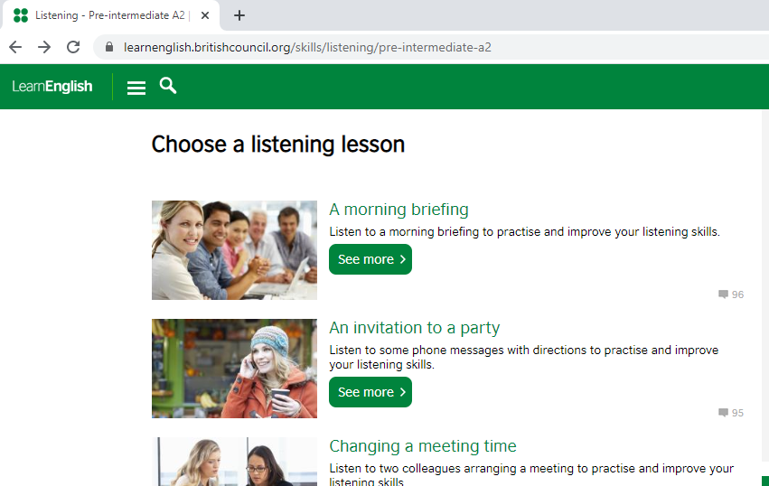

Music Practice

- Getting used to music through a cochlear implant isn’t easy and doesn’t work for everyone. Putting in some intensive practice can really pay off if this is an area you want to work on.
- Some on line practice can be an important part of your music practice schedule.

Advanced Bionic’s Musical Atmospheres
https://advancedbionics.com/in/en/home/products/solution-finder/music-solutions.html

- This is a popular programme which looks at different aspects of music appreciation a structured way working at different levels of difficulty.

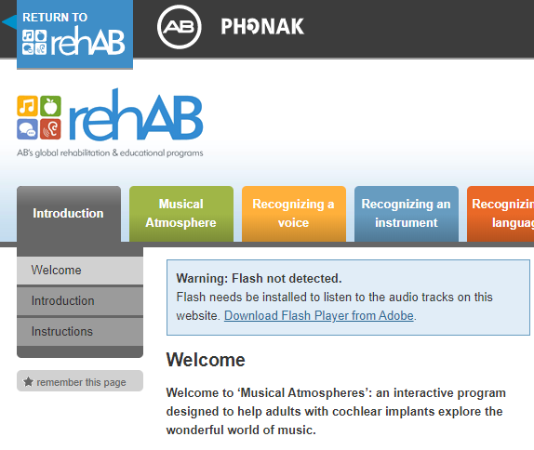

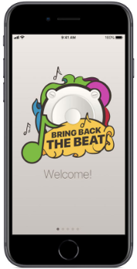
Cochlear – Bring Back the Beat

- Available via Google Play and the App Store.
- This has games and activities to help you develop your appreciation of different aspects of music.
- Its structured at different levels for different abilities.

Other Ways to Listen to Music

- With music it helps to know what you are listening to as quickly as possible.
- Music sounds very different at first and you might not recognise anything you hear.
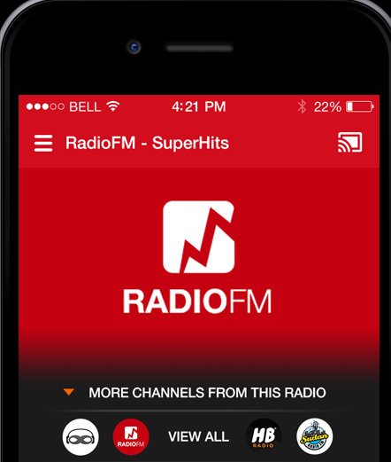
- If you put on a song you know well your brain will be actively reaching for the information it has stored about that song to help you try to make sense of how you are hearing it with your cochlear implant.
- Using radio apps or websites is useful because you can usually see the name of the song being played.
- YouTube also works well for music.
- You will be able to find any song you want to try.
- You can watch videos and performances and find the lyrics to the song which are all visual clues that will help you put the whole song together eventually.
We hope these ideas are useful.
Let us know if you find any listening activities that you want to share with other CI users!

Accessible Information
If you need this information in another format or language, please ask a member of staff.

Smoking
Bradford Teaching Hospitals NHS Foundation Trust is a smoke-free organisation. You are not permitted to smoke or use e-cigarettes in any of the hospital buildings or grounds.

Named Author:
Review Date:

